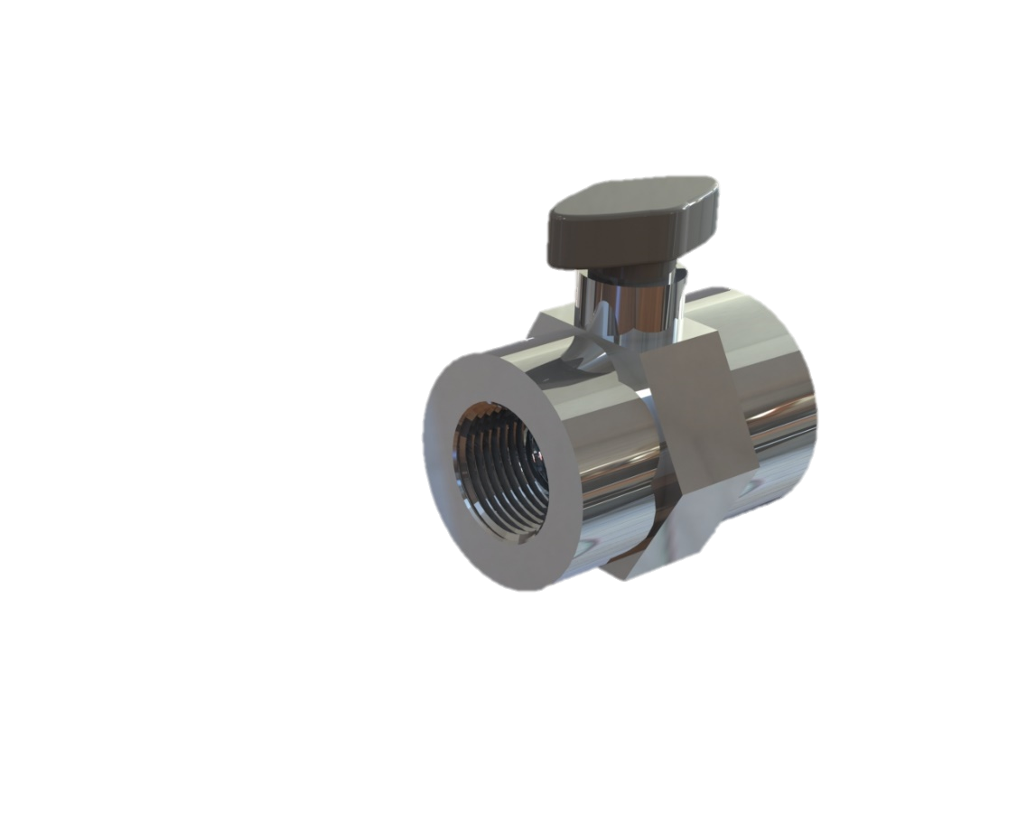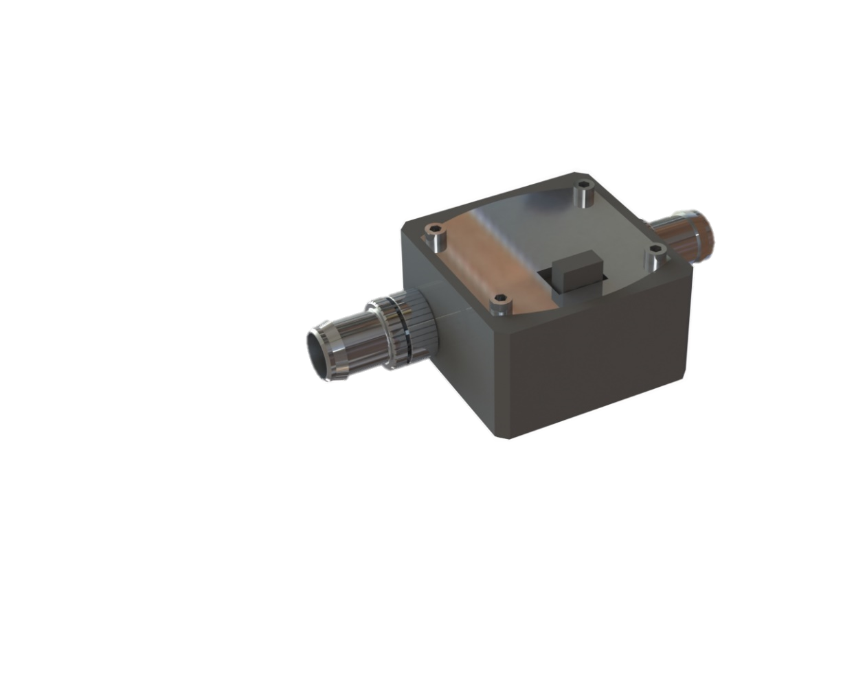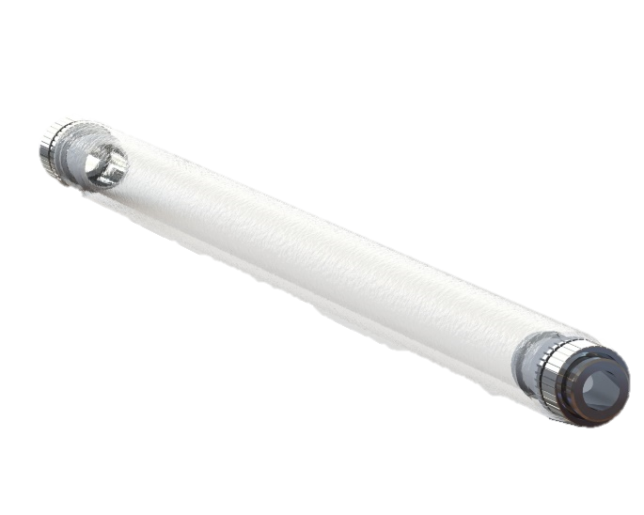Put the icon behind the box below to make it semi-transparent, and then use the snipping tool to take a screenshot of the area just inside the box.